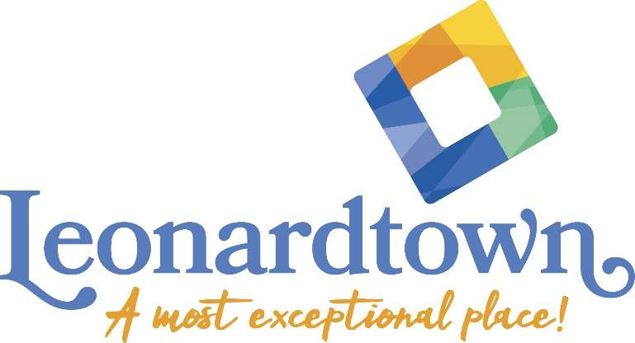

2024 Leonardtown Façade Improvement Grant Program Application

Deadline for Application
May 10, 2024

1. I, the applicant, have read the Façade Improvement Guidelines for Downtown Leonardtown and understand the criteria for approval of my application.

2. I further understand and agree that this is a “GRANT PROGRAM” and that this is not a guarantee of acceptance for funding. I further understand the process for acceptance.

3. It is expressly understood and agreed that the applicant shall be solely
responsible for all safety conditions and compliance with all safety regulations, building codes, ordinances, and other applicable regulations. A Leonardtown building permit may be required.

4. It is expressly understood and agreed that work completed prior to final
approval is ineligible for funding.

5. It is expressly understood and agreed that the applicant will not seek to hold the
the Town of Leonardtown, its agents, employees, officers and/or directors liable
for any property damage, personal injury, or other loss related in any way to the Façade Improvement Program.

6. The applicant shall be responsible for maintaining sufficient insurance
coverage for property damage and personal injury liability relating to the
Façade Improvement Program.

7. The applicant agrees to maintain the property and improvements, including, but not limited to, promptly removing graffiti, sweeping, and shoveling in front of the property.

8. The applicant authorizes the Town of Leonardtown to promote an approved project, including but not limited to displaying a sign at the site, during and after construction, and using photographs and descriptions of the project in materials and press releases.

9. The Town of Leonardtown reserves the right to make changes in the guidelines of the Façade Improvement Program between projects.

Signature of Applicant ____________________________________________

Date __________________________

If the applicant is not the property owner, please have the property owner or an authorized representative review the application and sign below.

As owner of the property at ________________________________________, I have reviewed the above application and authorize the operator of _________________________ at said address to perform the façade improvements described above as part of the Leonardtown Façade Improvement Program.

Signature of Property Owner __________________________________________

Date ___________________________

FY24 Leonardtown Program Application for Façade Improvement

General and Background Information

Name of Applicant/and business name if applicable: _____________________________________________________________

Address: ______________________________________________________

Telephone (Cell): __________________________

(Work): ___________________________

Address of work: ______________________________________________

Owner of address where work will be performed (if other than applicant):
____________________________________________________________

Address of owner: _____________________________________________

Telephone Number: ____________________________

Type of work to be completed: ____________________________________

_____________________________________________________________

_____________________________________________________________

_____________________________________________________________

_____________________________________________________________

*Attach cost estimates, budget, before photos, & supporting documentation.

Cost of work to be completed: ___________________

Amount of funding requested to complete work: ______________

Estimated date to start work: ________________________

Estimated completion date: _________________________

Current Use of Building
1st Floor ________________________________________________

2nd Floor ________________________________________________

3rd Floor ________________________________________________

Will uses change following completion of this project? Yes ___ No ___
If yes please explain. ______________________________________
_____________________________________________________________

Below, the applicant acknowledges his understanding that all local and
state building codes and laws will apply. The applicant agrees to match 1:1 the dollar amount of the project.

I, the applicant, have read and understand the Leonardtown Façade Improvement Program and agree to abide by the conditions as set forth in this Program. I hereby affirm that all information included on this form is true and accurate to the best of my knowledge.

Signature of Applicant: ______________________________ Date: __________ Printed Name ___________________________

Signature of Owner consenting to work to be performed on said property:

_______________________________________________ Date: ________
Printed Name _________________________ Phone # _________________

Approval of Leonardtown Town Administrator
Signed: ________________________________________ Date: ___________

Amount of funds approved by Leonardtown Façade Improvement Committee:
_______________________________________________________________

