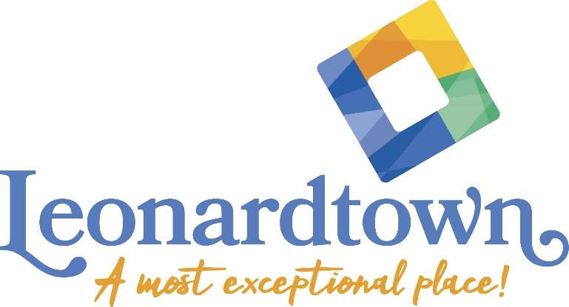

Leonardtown Façade Improvement Grant Program
Deadline for Application May 10, 2024

Program Overview & Guidelines

The Façade Improvement Grant Program is meant to aid building or business owners interested in improving the exterior of their buildings and shops spurring economic development and revitalization in the targeted area of downtown Leonardtown (see Exhibit 1). The program offers grants up to $10,000 with a 1:1 dollar match.

The program is administered by the Town Administrator and the Façade Review Committee. The committee is made up of Town Staff, Leonardtown business owners, property owners and residents.

This program is funded by a grant from the Maryland Department of Housing and Community Development (DHCD) for façade improvements to commercial properties with the goal to assist as many qualified projects as funding will allow. The grant program will be offered with a well-publicized deadline. If funds are not fully expended on the initial round, the grant will be offered on an ongoing basis until expended. The award amount is based on evaluation criteria, available funding, and number of requests. New businesses and property owners are encouraged to apply. Additionally, first-time applicants with high-impact projects may score higher during project evaluation. The Façade Review Committee will have discretion to make exceptions to the guidelines due to special situations.

Grants are administered on a reimbursement basis and final reports are due prior to reimbursement.

Priority may be given in the following situations:

- Buildings that will keep historical integrity
- Buildings that contain retail uses over those that contain other businesses
- Coordinated efforts of contiguous properties over individual properties
- Front façade projects over other parts of the building
- Renovation projects over new construction
- Commercial/income-producing buildings over those owned by public agencies
- ADA improvements

Types of projects eligible for funding include (but are not limited to):

1. Exterior painting, cleaning, or paint removal
2. Removing inappropriate or incompatible exterior finishes/materials
3. Restoring exterior finishes and materials
4. Recessing/reconfiguring of existing doors and entrances
5. Repairing or replacing existing storefront window systems
6. Signs (new, repairing, removing, and replacing)
7. Exterior building and sign lighting, display area lighting
8. Awnings; new, repairs, or replacement of existing
9. Repair or replacing architectural details or materials
10. Other improvements approved by the committee

Projects that contribute to a lesser degree to overall project ranking:

- Fencing
- Landscaping
- Outdoor seating
- Parking lots and other hardscaping (except if open to customers/the public and complementary to façade improvement to the business’s main building)

Ineligible projects include:

- Improvements made prior to grant approval
- Banners and vinyl signs
- Trash containers
- Improvements not visible from the property’s adjoining corridors
- Roof work, except where considered part of the façade
- Interior rehabilitation or decoration
- Improvements to vacant properties
- Construction work on any new building or facility, including substantial additions to an existing building
- Refinancing of existing debt
- Inventory or equipment
- Sweat equity (payment for owner’s own labor)
- General business operational expenses

Program funds can only be used for the project as detailed in the award agreement at the approved location. Program funds cannot include or support projects for which the primary use of the project includes: pawn shops, gun shops, tanning salons, massage parlors, adult video/book shop, adult entertainment facilities, check cashing facilities, gambling facilities, tattoo parlors or liquor stores. Projects can be on religious owned properties, but funding cannot be used to pay for projects that are part of a particular religious practice. Awardee shall use award funds solely to support nonsectarian, secular projects.
Attached as Exhibit 2 are examples of façade improvements - before and after photos prepared by Mahan Rykiel Associates.

Exhibit 3 Design Guidelines include excerpts from the Façade Improvement Workshop by Mahan Rykiel, held 1/22/18.

Application evaluation criteria and respective weights are as follows:

Project Impact – 50%: Overall impact of the project in the Leonardtown Downtown area. Does the project restore historical or architectural significance to the building; does it eliminate a previous liability for the area; will the project make contributions to business retention to Downtown; and will pedestrian traffic be increased because of the project?

Financial Leverage – 20%: What is the percentage of private investment in the project? While this is a 50% matching grant, projects that leverage more private investment may be evaluated higher during the ranking process.

Permanence/Maintenance – 15%: How permanent are the improvements and is there a maintenance plan for the improvements? Does the business own the building; if not, how much time remains on the lease?

Community Contribution – 15%: Is the area around the business kept clean and free of debris and nuisance issues? Does the applicant actively promote downtown and their own businesses?

Application Process

- A meeting with the Main Street Manager is recommended prior to application submission.
- Complete applications must be submitted to Town Hall by the submission deadline of May 10, 2024. Property must be located within the grant program area.
- Existing site photos should be included.
- A description of improvements must be included and photos of materials or color samples if available.
- A project budget with supporting documentation.
- Proposals from contractors considered for performing the work.

The review committee will review the applications and anticipates awardees will be notified in writing before the end of June. The awardee will then work with Town staff for the necessary permits and approvals. Work cannot begin until all approvals have been received.

Prior to work beginning, a grant agreement must be signed for the approved project. If work is being done on a rented property the signature of the building owner is needed on the application. All work must be completed within 6 months of the signed grant agreement. Grant extensions may be made based on extenuating circumstances. Any changes to the scope of improvements must be approved in advance, and in writing, by contacting the Main Street Manager.

All projects are subject to the Maryland Historical Trust Act, which requires staff to consult with DHCD and the Maryland Historical Trust on projects seeking financial assistance, and avoid adversely affecting properties that are listed on the National Register of Historic Places OR are considered eligible for listing.

Town staff will contact grantees for project updates on a quarterly basis and then compile a progress report for all applicable projects for submission to MD DHCD. It is essential that grantees provide project update information when requested, as missing or late reports may affect the Town’s future eligibility for these grants.

A final report (after photos, paid invoices and/or copies of receipts itemizing all eligible costs, and copies of cancelled checks) is required upon completion to receive reimbursement.

Work must conform with the description provided in the executed grant agreement, unless otherwise previously approved.

A committee member will perform a final inspection of the improvements upon completion. Leonardtown reserves the right to cancel the agreement in the event of failure to comply with the regulations.

The Town of Leonardtown may promote an approved project including, but not limited to, using photographs and descriptions of the project in press releases.

Upon completion of the project, applicant is responsible to ensure that all debris and building materials will be disposed of properly. The applicant further agrees to maintain the property and improvements going forward.

Contact the Main Street Manager with questions regarding this program.

Emily Stagner, Main Street Manager
Phone: 301-475-9791
Emily.stagner@leonardtownmd.gov

